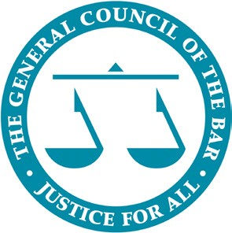

Latin American Lawyers’ Exchange Programme 2019
Application form

In order to apply to participate in the programme please read the attached guidance notes, complete this application form and return it to IntlEvents@BarCouncil.org.uk by 17:00 on Monday 21 January 2019.

We will aim to let you know the outcome of your application within two weeks of the deadline date.

Personal Details

Name

Firm name and address

Work telephone number

Mobile telephone number

Email address

Number of years Post Qualification Experience
Languages spoken

How did you find out about this programme?

Experience and motivations

Please outline your main areas of legal practice

Please summarise any experience you have of international work or study, particularly in relation to England & Wales

Please describe your main objectives for the visit and why you think you should be selected

Please indicate any other information you consider relevant (e.g. membership of foreign bar associations or bilateral lawyers associations participation in international legal conferences etc.)

